In a lawyer appointment management system, a client **can** register by providing a unique username, first name, last name, date of birth, contact number, email, and password. Each address consists of a city name, street number, and house number. A lawyer can also register using the same credentials, with the addition of a bar registration number and his/her specialization. Each client and lawyer can **do** log in using their valid username and password. After Log In each client and lawyer Identified with unique ID and other entities.

A client can **book** multiple appointments, and each appointment stores the unique appointment ID, date, time, status, and an optional description, while a lawyer **attends** appointments from many clients. One lawyer can handle multiple appointments and cases, but each appointment is associated with exactly one lawyer and one client.

A legal case is identified by a case ID and contains case type, case description, and case status (either Ongoing or Closed). Each case is **managed by** a client and **handled by** a lawyer, and every case must **belong to** exactly one court. Courts are identified by a court ID, and the system also stores the court type (Supreme, High, or District), court location, division, and district information.

Payments are managed carefully in the system and are recorded with payment ID, amount, date, method (Cash, Mobile Banking, or Bank Transfer), and status (Paid or Unpaid). Each payment must be **linked** to an appointment. Every payment is always **initiated by** a client.

The review system allows clients to give feedback to lawyers. A review is uniquely identified by an ID and includes the review date, rating (between 1 and 5), and optional comments. A client can give only one review per appointment, preventing duplicate feedback. Reviews are **associated with** an appointment where lawyers get average ratings updated.

ER DIAGRAM

Normalization:

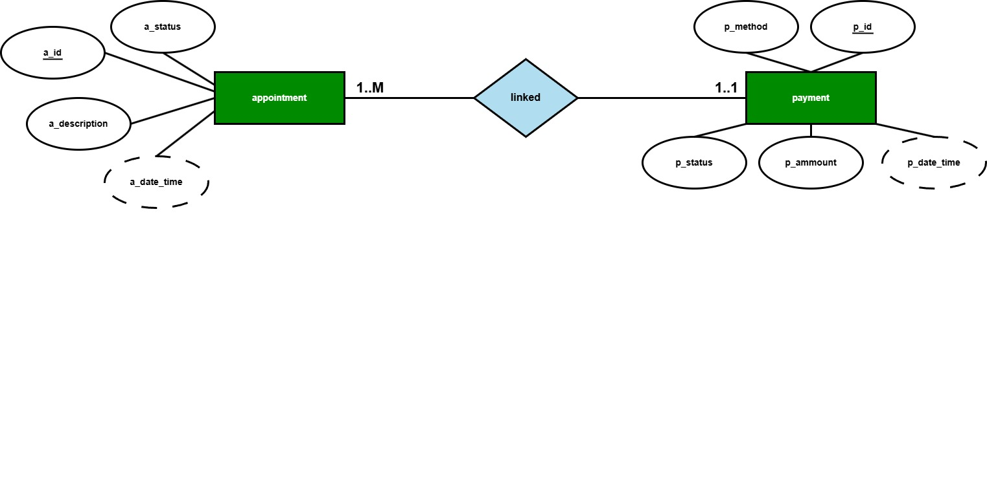

**linked:**  
**unf:**  
app_id, app_status, app_description, app_date_time, p_id, p_method, p_status, p_ammount, p_date_time

**1nf:** no multivalued attribute. (same as unf)  
app_id, app_status, app_description, app_date_time, p_id, p_method, p_status, p_ammount, p_date_time

**2nf:**

1. app_id, app_status, app_description, app_date_time
2. p_id, p_method, p_status, p_ammount, p_date_time

**3nf:**

There is no transitive attribute. Relation is already in 3nf.

1. app_id, app_status, app_description, app_date_time
2. p_id, p_method, p_status, p_ammount, p_date_time

**Table creation:**

1. app_id, app_status, app_description, app_date_time
2. p_id, p_method, p_status, p_ammount, p_date_time, **app_id**

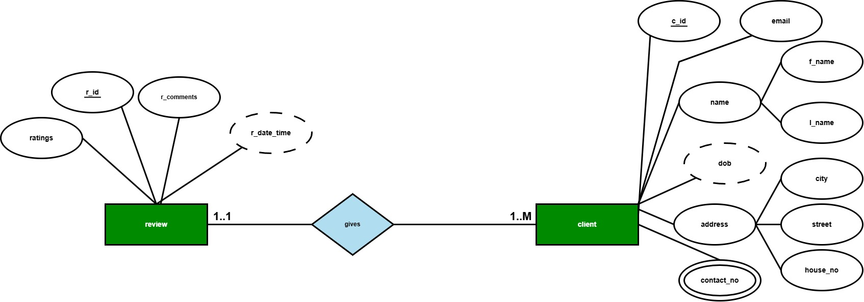

**gives:**

**unf:**  
r_id, r_comment, ratings, r_date_time, c_id, email, f_name, l_name, city, street, house_no, contact_no, dob

**1nf:** contact_no is a multivalued attribute.  
r_id, r_comment, ratings, r_date_time, c_id, email, f_name, l_name, city, street, house_no, contact_no, dob

**2nf:**

1. r_id, r_comment, ratings, r_date_time
2. c_id, email, contact_no, f_name, l_name, city, street, house_no, dob

**3nf:**

Name and Address are Transitive attribute.

1. r_id, r_comment, ratings, r_date_time
2. c_id, email, contact_no, dob
3. name_id, f_name, l_name
4. a_id, city, street, house_no

**Table creation:**

1. r_id, r_comment, ratings, r_date_time, **name_id**, **a_id**, **c_id**
2. c_id, email, contact_no, dob
3. name_id, f_name, l_name
4. a_id, city, street, house_no

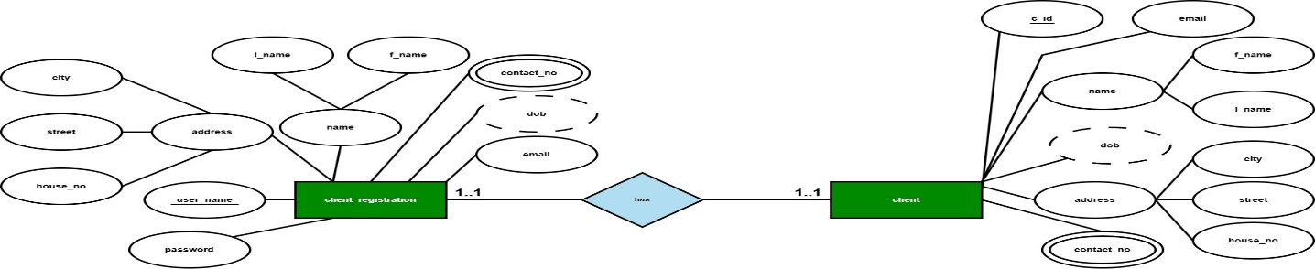

**has:**

**unf:**

user_name, email, password, dob, contact_no, f_name, l_name, city, street, house_no, c_id, email, f_name, l_name, city, street, house_no, contact_no, dob

**1nf:** contact_no is a multivalued attribute.

user_name, email, password, dob, contact_no, f_name, l_name, city, street, house_no, c_id, email, f_name, l_name, city, street, house_no, contact_no, dob

**2nf:**

1. user_name, email, password, dob, contact_no, f_name, l_name, city, street, house_no
2. c_id, email, f_name, l_name, city, street, house_no, contact_no, dob

**3nf:**Name and Address are Transitive attribute.

1. user_name, email, password, dob, contact_no
2. name_id, f_name, l_name
3. a_id, city, street, house_no
4. c_id, email, contact_no, dob

**Table creation:**

1. user_name, email, password, dob, contact_no, **name_id, a_id, c_id**
2. name_id, f_name, l_name
3. a_id, city, street, house_no
4. c_id, email, contact_no, dob

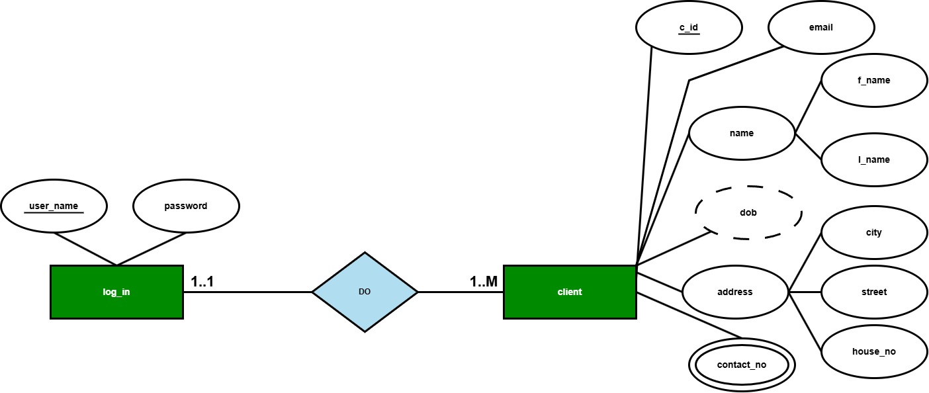

**do**

unf:

user_name, password, c_id, email, f_name, l_name, city, street, house_no, contact_no, dob

**1nf:** contact_no is a multivalued attribute.

user_name, password, c_id, email, f_name, l_name, city, street, house_no, contact_no, dob

**2nf:**

1. user_name, password
2. c_id, email, f_name, l_name, city, street, house_no, contact_no, dob

**3nf:**

Name and Address are Transitive attribute.

1. user_name, password
2. c_id, email, contact_no, dob
3. name_id, f_name, l_name
4. a_id, city, street, house_no

**Table creation:**

1. user_name, password, **c_id, name_id, a_id**
2. c_id, email, contact_no, dob
3. name_id, f_name, l_name
4. a_id, city, street, house_no

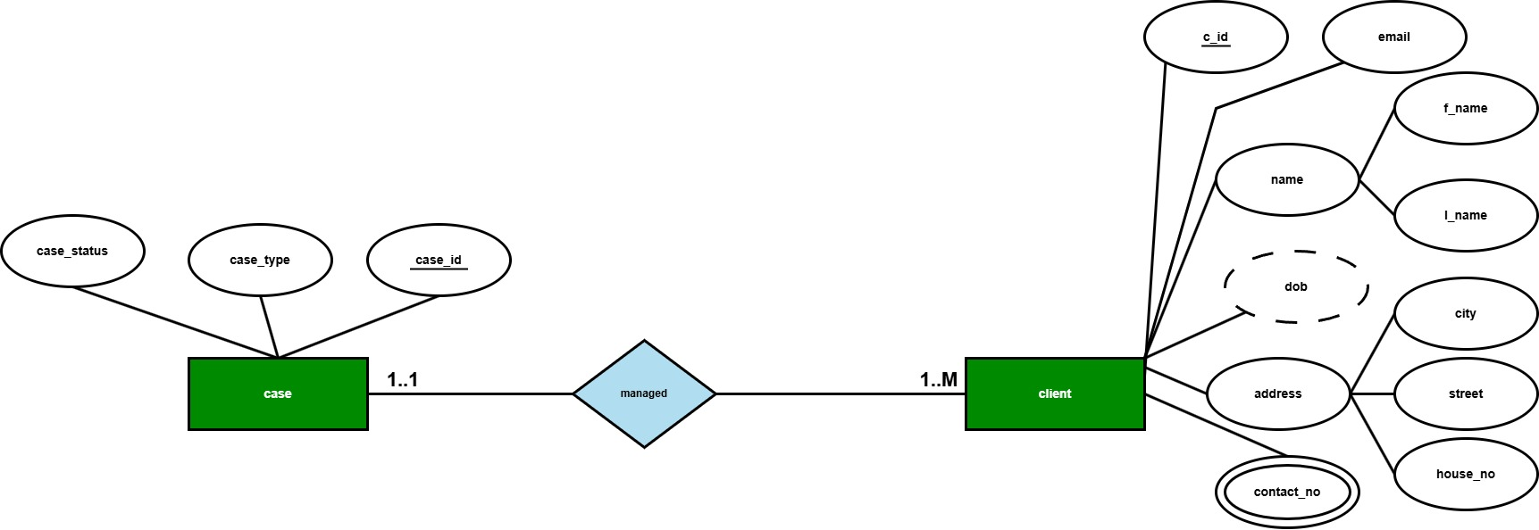

**managed:**

**unf:**

case_id, case_status, case_type, c_id, email, f_name, l_name, city, street, house_no, contact_no, dob

**1nf:** contact_no is a multivalued attribute.

case_id, case_status, case_type, c_id, email, f_name, l_name, city, street, house_no, contact_no, dob

**2nf:**

1. case_id, case_status, case_type
2. c_id, email, f_name, l_name, city, street, house_no, contact_no, dob

**3nf:** Name and Address are Transitive attribute

1. case_id, case_status, case_type
2. c_id, email, contact_no, dob
3. name_id, f_name, l_name
4. a_id, city, street, house_no

**Table creation:**

1. case_id, case_status, case_type, , **c_id, name_id, a_id**
2. c_id, email, contact_no, dob
3. name_id, f_name, l_name
4. a_id, city, street, house_no

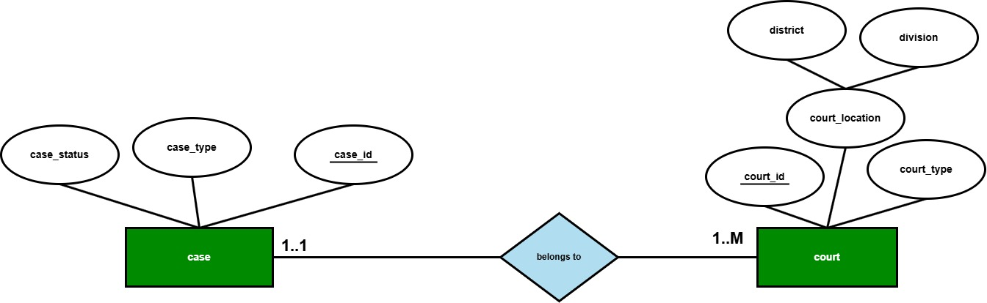

**belongs to:**

**unf:**

case_id, case_status, case_type, court_id, court_type, district, division

**1nf:** no multivalued attribute. (same as unf)

case_id, case_status, case_type, court_id, court_type, district, division

**2nf:**

1. case_id, case_status, case_type
2. court_id, court_type, district, division

**3nf:**

Court_Location is a Transitive attribute

1. case_id, case_status, case_type
2. court_id, court_type
3. loc_id, district, division

**Table creation:**

1. case_id, case_status, case_type, **court_id, loc_id**
2. court_id, court_type, case_id
3. loc_id, district, division

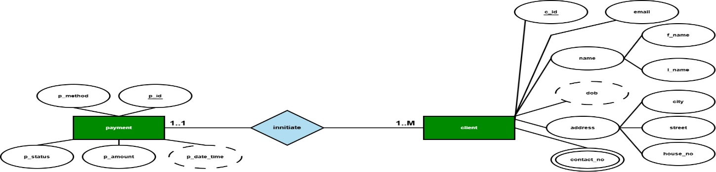

**initiate:**

**unf:**

p_id, p_method, p_status, p_amount, p_date_time, c_id, email, f_name, l_name, city, street, house_no, contact_no, dob

**1nf**: contact_no is a multivalued attribute.

p_id, p_method, p_status, p_amount, p_date_time, c_id, email, f_name, l_name, city, street, house_no, contact_no, dob

**2nf:**

1. p_id, p_method, p_status, p_amount, p_date_time
2. c_id, email, f_name, l_name, city, street, house_no, contact_no, dob

**3nf:**

Name and Address are Transitive attribute

1. p_id, p_method, p_status, p_amount, p_date_time
2. c_id, email, contact_no, dob
3. name_id, f_name, l_name
4. a_id, city, street, house_no

**Table creation:**

1. p_id, p_method, p_status, p_amount, p_date_time, **c_id, name_id, a_id**
2. c_id, email, contact_no, dob
3. name_id, f_name, l_name
4. a_id, city, street, house_no

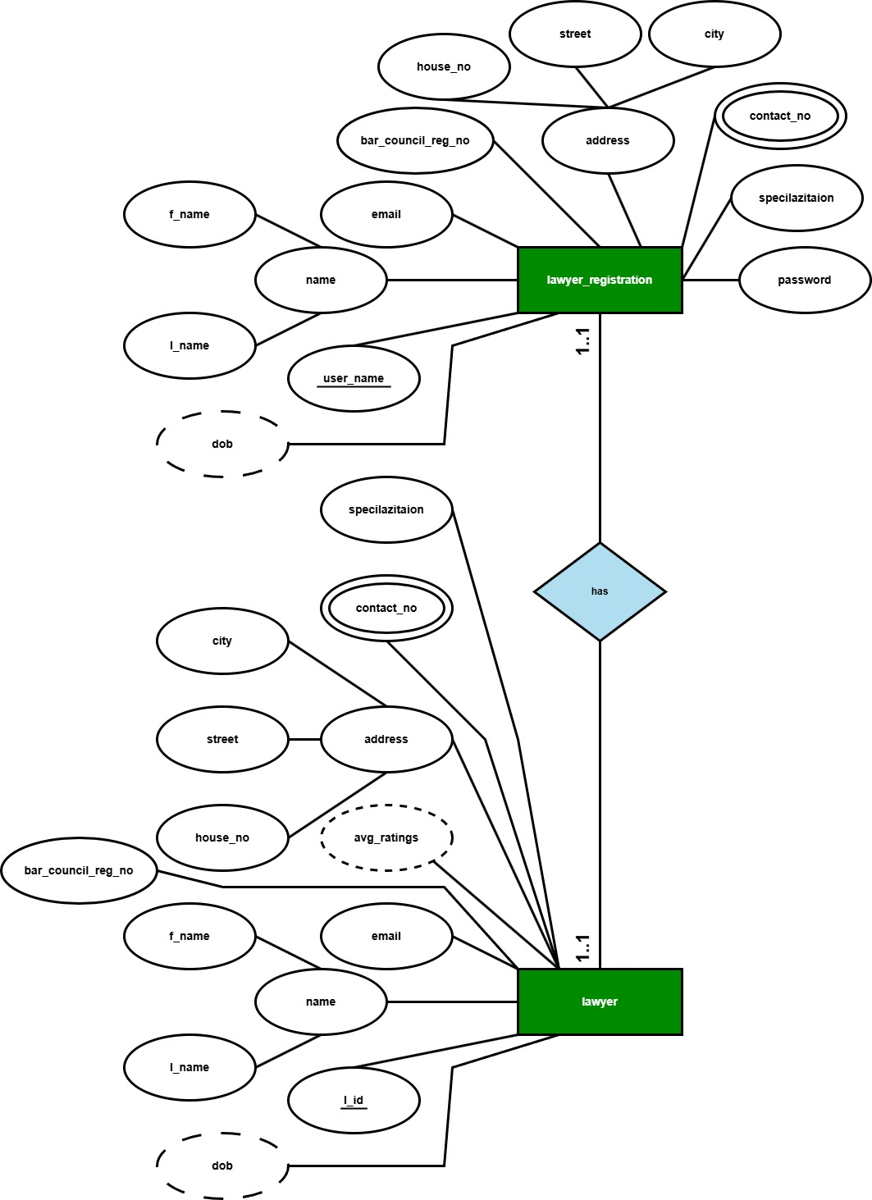

**has:**

**unf:**

l_id, email, bar_council_reg_no, avg_ratings, specialization, contact_no, dob, f_name, l_name, city, street, house_no, user_name, password, email, bar_council_reg_no, specialization, contact_no, dob, f_name, l_name, city, street, house_no

**1nf**: contact_no is a multivalued attribute.

l_id, email, bar_council_reg_no, avg_ratings, specialization, contact_no, dob, f_name, l_name, city, street, house_no, user_name, password, email, bar_council_reg_no, specialization, contact_no, dob, f_name, l_name, city, street, house_no

**2nf:**

1. l_id, email, bar_council_reg_no, avg_ratings, specialization, contact_no, dob, f_name, l_name, city, street, house_no
2. user_name, password, email, bar_council_reg_no, specialization, contact_no, dob, f_name, l_name, city, street, house_no

**3nf:** Name and Address are Transitive attribute

1. l_id, email, bar_council_reg_no, avg_ratings, specialization, contact_no, dob
2. name_id, f_name, l_name
3. a_id, city, street, house_no
4. user_name, password, email, bar_council_reg_no, specialization, contact_no, dob

**Table creation:**

1. l_id, email, bar_council_reg_no, avg_ratings, specialization, contact_no, dob, **name_id, a_id, user_name**
2. name_id, f_name, l_name
3. a_id, city, street, house_no
4. user_name, password, email, bar_council_reg_no, specialization, contact_no, dob

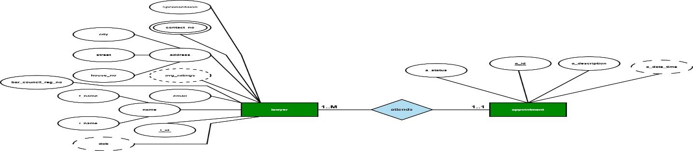

**attends:**

**unf:** app_id, app_status, app_description, app_date_time, l_id, email, bar_council_reg_no, avg_ratings, specialization, contact_no, dob, f_name, l_name, city, street, house_no

**1nf:** contact_no is a multivalued attribute.

app_id, app_status, app_description, app_date_time, l_id, email, bar_council_reg_no, avg_ratings, specialization, contact_no, dob, f_name, l_name, city, street, house_no

**2nf:**

1. app_id, app_status, app_description, app_date_time
2. l_id, email, bar_council_reg_no, avg_ratings, specialization, contact_no, dob, f_name, l_name, city, street, house_no

**3nf:**

Name and Address are Transitive attribute

1. app_id, app_status, app_description, app_date_time
2. name_id, f_name, l_name
3. a_id, city, street, house_no
4. l_id, email, bar_council_reg_no, avg_ratings, specialization, contact_no, dob

**Table creation:**

1. app_id, app_status, app_description, app_date_time, **name_id, a_id, l_id**
2. name_id, f_name, l_name
3. a_id, city, street, house_no
4. l_id, email, bar_council_reg_no, avg_ratings, specialization, contact_no, dob

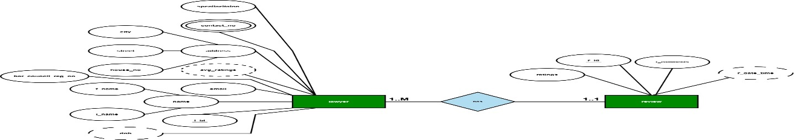

**has:**

**unf:** r_id, ratings, r_comments, r_date_time, l_id, email, bar_council_reg_no, avg_ratings, specialization, contact_no, dob, f_name, l_name, city, street, house_no

**1nf:** contact_no is a multivalued attribute.

r_id, ratings, r_comments, r_date_time, l_id, email, bar_council_reg_no, avg_ratings, specialization, contact_no, dob, f_name, l_name, city, street, house_no

**2nf:**

1. r_id, ratings, r_comments, r_date_time
2. l_id, email, bar_council_reg_no, avg_ratings, specialization, contact_no, dob, f_name, l_name, city, street, house_no

**3nf:**

Name and Address are Transitive attribute

1. r_id, ratings, r_comments, r_date_time
2. name_id, f_name, l_name
3. a_id, city, street, house_no
4. l_id, email, bar_council_reg_no, avg_ratings, specialization, contact_no, dob

**Table creation:**

1. r_id, ratings, r_comments, r_date_time, **name_id, a_id, l_id**
2. name_id, f_name, l_name
3. a_id, city, street, house_no
4. l_id, email, bar_council_reg_no, avg_ratings, specialization, contact_no, dob

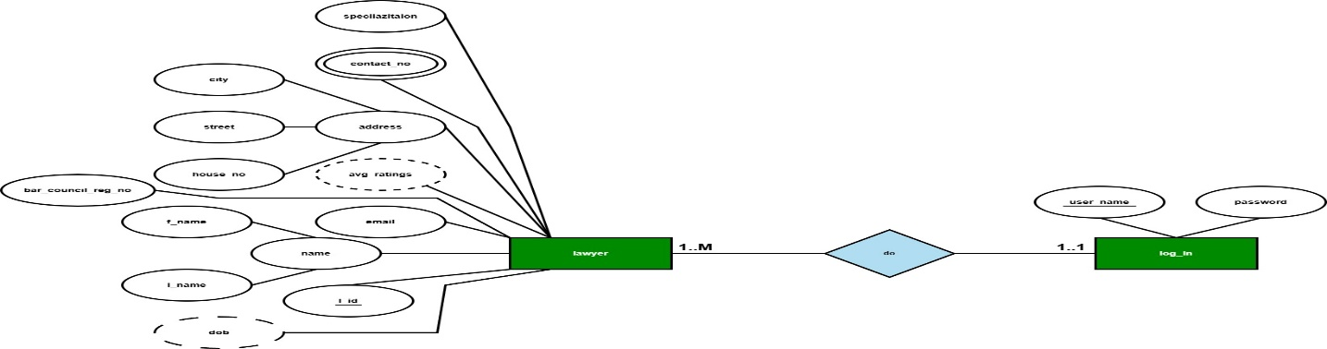

**do:**

**unf:** user_name, password, l_id, email, bar_council_reg_no, avg_ratings, specialization, contact_no, dob, f_name, l_name, city, street, house_no

**1nf:** contact_no is a multivalued attribute.

user_name, password, l_id, email, bar_council_reg_no, avg_ratings, specialization, contact_no, dob, f_name, l_name, city, street, house_no

**2nf:**

1. user_name, password
2. l_id, email, bar_council_reg_no, avg_ratings, specialization, contact_no, dob, f_name, l_name, city, street, house_no

**3nf:**

Name and Address are Transitive attribute

1. user_name, password
2. name_id, f_name, l_name
3. a_id, city, street, house_no
4. l_id, email, bar_council_reg_no, avg_ratings, specialization, contact_no, dob

**Table creation:**

1. user_name, password, **name_id, a_id, l_id**
2. name_id, f_name, l_name
3. a_id, city, street, house_no
4. l_id, email, bar_council_reg_no, avg_ratings, specialization, contact_no, dob

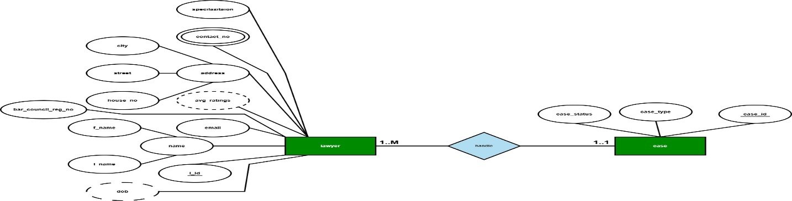

**handle:**

**unf:** case_id, case_status, case_type, l_id, email, bar_council_reg_no, avg_ratings, specialization, contact_no, dob, f_name, l_name, city, street, house_no

**1nf:** contact_no is a multivalued attribute.

case_id, case_status, case_type, l_id, email, bar_council_reg_no, avg_ratings, specialization, contact_no, dob, f_name, l_name, city, street, house_no

**2nf:**

1. case_id, case_status, case_type
2. l_id, email, bar_council_reg_no, avg_ratings, specialization, contact_no, dob, f_name, l_name, city, street, house_no

**3nf:**

Name and Address are Transitive attribute

1. case_id, case_status, case_type
2. name_id, f_name, l_name
3. a_id, city, street, house_no
4. l_id, email, bar_council_reg_no, avg_ratings, specialization, contact_no, dob

**Table creation:**

1. case_id, case_status, case_type, **name_id, a_id, l_id**
2. name_id, f_name, l_name
3. a_id, city, street, house_no
4. l_id, email, bar_council_reg_no, avg_ratings, specialization, contact_no, dob

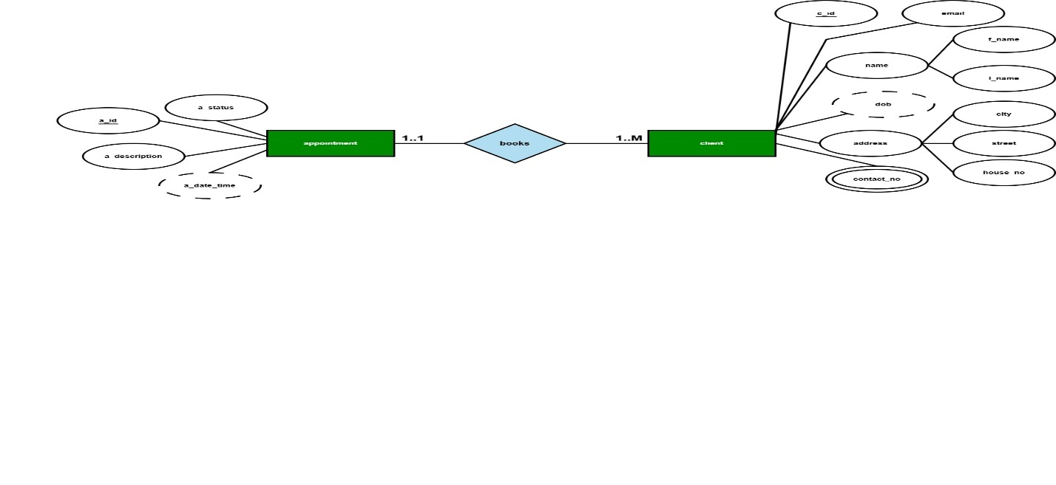

**books:**

**unf:** app_id, app_status, app_description, app_date_time, c_id, email, f_name, l_name, city, street, house_no, contact_no, dob

**1nf:** contact_no is a multivalued attribute.

app_id, app_status, app_description, app_date_time, c_id, email, f_name, l_name, city, street, house_no, contact_no, dob

**2nf:**

1. app_id, app_status, app_description, app_date_time
2. c_id, email, f_name, l_name, city, street, house_no, contact_no, dob

**3nf:**

Name and Address are Transitive attribute

1. app_id, app_status, app_description, app_date_time
2. name_id, f_name, l_name
3. a_id, city, street, house_no
4. c_id, email, contact_no, dob

**Table creation:**

1. app_id, app_status, app_description, app_date_time, **name_id, a_id, c_id**
2. name_id, f_name, l_name
3. a_id, city, street, house_no
4. c_id, email, contact_no, dob

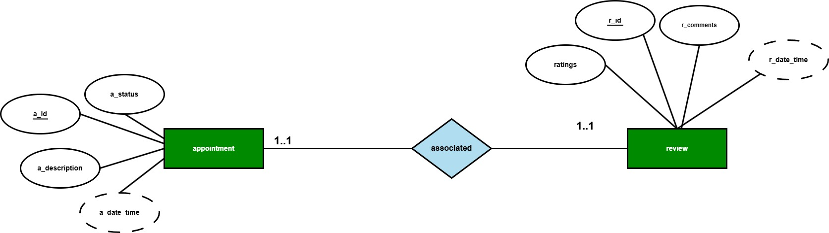

**associate:**

**unf:** app_id, app_status, app_description, app_date_time, r_id, ratings, r_comments, r_date_time

**1nf:** no multivalued attribute. (same as unf)

app_id, app_status, app_description, app_date_time, r_id, ratings, r_comments, r_date_time

**2nf:**

1. app_id, app_status, app_description, app_date_time
2. r_id, ratings, r_comments, r_date_time

**3nf:**

There is no transitive attribute. Relation is already in 3nf.

1. app_id, app_status, app_description, app_date_time
2. r_id, ratings, r_comments, r_date_time

**Table creation:**

1. app_id, app_status, app_description, app_date_time
2. r_id, ratings, r_comments, r_date_time, **app_id**

**Temporary Tables:**

1. app_id, app_status, app_description, app_date_time
2. p_id, p_method, p_status, p_ammount, p_date_time, **app_id**
3. r_id, r_comment, ratings, r_date_time, **name_id**, **a_id**, **c_id**
4. c_id, email, contact_no, dob
5. name_id, f_name, l_name
6. a_id, city, street, house_no
7. user_name, email, password, dob, contact_no, **name_id, a_id, c_id**
8. name_id, f_name, l_name
9. a_id, city, street, house_no
10. c_id, email, contact_no, dob
11. user_name, password, **, name_id, c_id, a_id**
12. c_id, email, contact_no, dob
13. name_id, f_name, l_name
14. a_id, city, street, house_no
15. case_id, case_status, case_type, **name_id , c_id, a_id**
16. c_id, email, contact_no, dob
17. name_id, f_name, l_name
18. a_id, city, street, house_no
19. case_id, case_status, case_type, **court_id, loc_id**
20. court_id, court_type, case_id
21. loc_id, district, division
22. p_id, p_method, p_status, p_amount, p_date_time, **c_id, name_id, a_id**
23. c_id, email, contact_no, dob
24. name_id, f_name, l_name
25. a_id, city, street, house_no
26. l_id, email, bar_council_reg_no, avg_ratings, specialization, contact_no, dob, **name_id, a_id, user_name**
27. name_id, f_name, l_name
28. a_id, city, street, house_no
29. user_name, password, email, bar_council_reg_no, specialization, contact_no, dob
30. app_id, app_status, app_description, app_date_time, **name_id, a_id, l_id**
31. name_id, f_name, l_name
32. a_id, city, street, house_no
33. l_id, email, bar_council_reg_no, avg_ratings, specialization, contact_no, dob
34. r_id, ratings, r_comments, r_date_time, **name_id, a_id, l_id**
35. name_id, f_name, l_name
36. a_id, city, street, house_no
37. l_id, email, bar_council_reg_no, avg_ratings, specialization, contact_no, dob
38. user_name, password, **name_id, a_id, l_id**
39. name_id, f_name, l_name
40. a_id, city, street, house_no
41. l_id, email, bar_council_reg_no, avg_ratings, specialization, contact_no, dob
42. case_id, case_status, case_type, **name_id, a_id, l_id**
43. name_id, f_name, l_name
44. a_id, city, street, house_no
45. l_id, email, bar_council_reg_no, avg_ratings, specialization, contact_no, dob
46. app_id, app_status, app_description, app_date_time, **name_id, a_id, c_id**
47. name_id, f_name, l_name
48. a_id, city, street, house_no
49. c_id, email, contact_no, dob
50. app_id, app_status, app_description, app_date_time
51. r_id, ratings, r_comments, r_date_time, **app_id**

**Final Tables:**

1. app_id, app_status, app_description, app_date_time
2. c_id, email, contact_no, dob
3. name_id, f_name, l_name
4. a_id, city, street, house_no
5. user_name, email, password, dob, contact_no, **name_id, a_id, c_id**
6. court_id, court_type, case_id
7. loc_id, district, division
8. p_id, p_method, p_status, p_amount, p_date_time, **c_id, name_id, a_id, app_id**
9. l_id, email, bar_council_reg_no, avg_ratings, specialization, contact_no, dob, **name_id, a_id, user_name**
10. user_name, email, password, bar_council_reg_no, specialization, contact_no, dob
11. r_id, ratings, r_comments, r_date_time, **name_id, a_id, l_id, c_id**
12. user_name, password, **name_id, a_id, l_id, c_id**
13. case_id, case_status, case_type, **name_id, a_id, l_id, c_id, court_id, loc_id**
14. app_id, app_status, app_description, app_date_time, **name_id, a_id, c_id, l_id**
15. r_id, ratings, r_comments, r_date_time, **app_id**